Whittonstall and Broomley First School
Executive Head Teacher Mrs Katie Jacobs

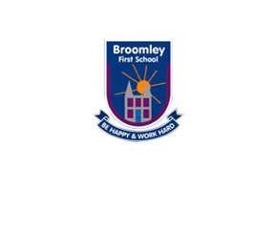
Whittonstall Main Road
Nr Consett Stocksfield
County Durham Northumberland
DH8 9JN NE43 7NN
Tel 01207 560325 Tel 01661842271
admin@whittonstall.northumberland.sch.uk admin@broomley.northumberland.sch.uk

17th February 2023

Dear Parents and Carers,
I am delighted to be able to write my first letter as the new Executive Headteacher of Broomley and Whittonstall First Schools. I feel incredibly privileged to be able to continue building upon the success that both schools have already achieved.
To give you a little background to my experience, back in 2019 I was appointed as Head Teacher of Prudhoe Castle First School where I had spent the previous three years as their Deputy Headteacher. Before this, I worked in large Primary schools in Newcastle where I held various leadership roles, including the role of SENCO.
Having worked in education for 18 years, I am very much aware of the responsibility that my staff and I have in ensuring that the highest standard of teaching and learning is achieved. We have a hugely committed team and wonderful children which, of course, is a great place for any new head to start! Alongside Mrs. Ridley as Deputy Headteacher and together with the unwavering support of the school team, we are extremely excited about the journey ahead.
The needs of the children are always paramount to decision-making within a school. I strongly believe in providing children with exciting, creative, and meaningful learning experiences, which will build their enthusiasm for learning and help them grow and develop positively in many different ways. I think it is crucial to involve the children and their families as partners in their education.
I am keen on building a whole school community that thrives on mutual respect and values positive relationships. I know how vital working in partnership with parents is for children to find school a positive and rewarding experience. As key educators in your children’s lives, I feel that it is important that you have a voice and that as a school we are approachable and allocate time to listen to your concerns, worries, or thoughts. Shortly I will be inviting parents into school for an informal coffee morning. This will be an opportunity to meet other parents and chat with me and other members of staff over a cup of coffee and a biscuit. Watch this space!
You can be assured that as Executive Headteacher, I will strive to create the best education for your child/children while they are members of our school families. Please introduce yourselves when you see me on the school gates as I am looking forward to meeting more of you in the coming weeks.
I hope you all have a restful half term and I look forward to welcoming you all when we return to school on Monday 27th February.
Thank you for your continued support.
Yours Sincerely,
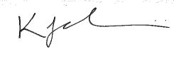
Katie Jacobs
Executive Head Teacher

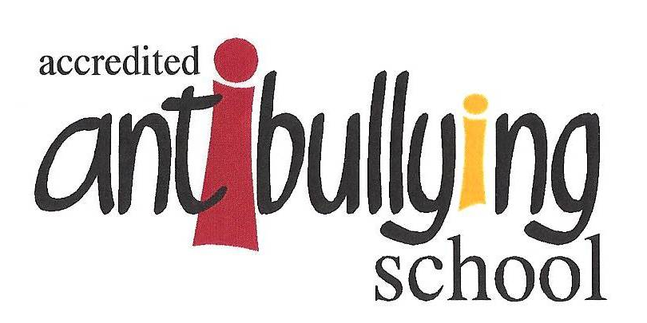
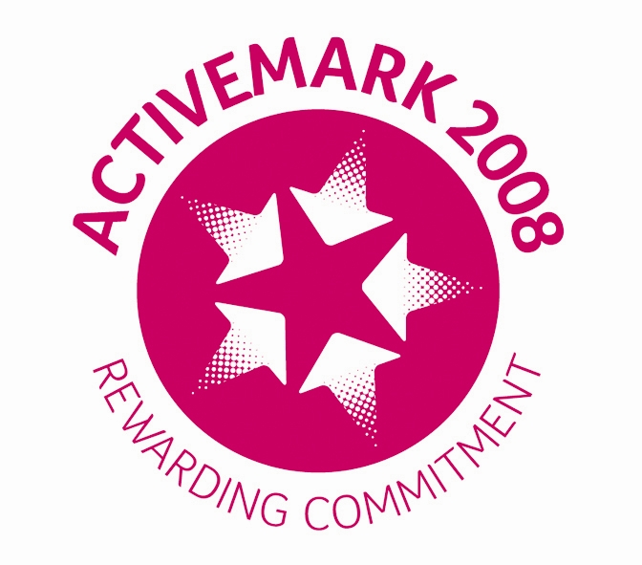
Broomley First School

